http://www.nyp.edu.sg/nyp/slot/u100/style/homepage/logo.jpg

|  |  |
| --- | --- |
|  | DM2335 Programming With Game Engine: Assignment 01 Proposal |
|  |  |
|  |  |

Sri Sham Haran; 155129R

Goh Zheng Yuan; 150377B

Yap Heng Soon; 155233A

Contents

Game Idea Concept 3

Gameplay elements 3

PowerUps 3

Extras (Additional task if ahead of time) 3

Monetization 3

Screenshots & Mockups 3

Screenshots of reference games 3

Mockups 4

Gameflow 4

Planned screens 4

Tasklists 4

Goh Zheng Yuan 4

YAP Heng Soon 4

Sri SHam Haran 5

# Game Idea Concept

Rocket Surge is a 2D Sidescrolling action game that involves the player controlling a main character that collects coins by rocket jumping* through complex levels while avoiding obstacles.

Coins collected can be used to purchase blind boxes that reveal different levels of power ups / cosmetics.

*Rocket Jumping - Launching rockets towards the ground to elevate the character

## Gameplay elements

### PowerUps

|  |  |
| --- | --- |
| Item | Description |
| Magnet | Pulls in nearby coin |
| Shield | Block 1 Attack |
| Booster | Boost through 400m in distance |

### Extras (Additional task if ahead of time)

#### Boss

#### Bomb Propulsion

#### Mines

* 1St tap to toss mine
* 2nd tap to jump
* 3rd tap to detonate

#### Enemies

# Monetization

Rocket Surge is monetized through the use of Ads hosted by Google AdSense and Micro-Transactions. Micro-Transactions would come in the form of blind boxes, currency and energy.

Currency allows player to purchase cosmetic items such that the player can customise the main character however they like with the given in-game cosmetic items.

# Screenshots & Mockups

## Screenshots of reference games

## https://lh3.googleusercontent.com/8JDlRVkAMDAWRdH7bRrSTaVDFm3FPyPTbiPnHgVVqJcxeu0fPL3zXQnmPzyflgJi94EFllYj4NxvacNzX_KoEg21Ahpj_-aup-hiTxUsPhfMOi1ad3FOWfZEkQEzvznQ35W235Gjhttps://lh5.googleusercontent.com/dQz2DTCSIC0Ik0gkSRMK0yAFF4f94JawglKgcHbKlax96i3jsq7MwFFfLmEGOK8XeOC5q4tWolmHovXnFmg6JuJhlzr79UIWS776Int9O9csRJyQElJ6Ae5CpOZI9kahSAuBDr1rMockups

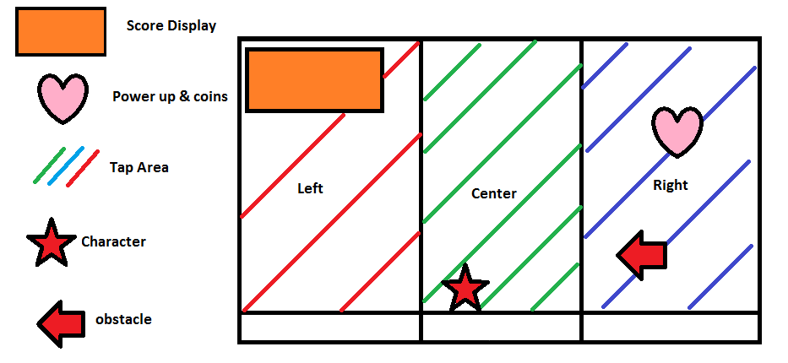

# Gameflow

## Planned screens

* Main Menu
* Shop
* Pre-Game Menu (To choose skins etc.)
* Gameplay
* Leaderboards & FB Connect
* Options

# Tasklists

## Goh Zheng Yuan

* Sprite Animation
* Parallax Background
* Obstacle and Coin spawning
* Micro-Transactions

## YAP Heng Soon

* Character Movement
* Missile & Missile mechanics
* Scene Manager
* Main Menu

## Sri SHam Haran

* UI
* Facebook integration
* Leaderboards
* Sound (SFX & BGM)
* Lighting